|  |
| --- |
| ASE TEAM 3&4  SYSTEM DOCUMENTATION HUSACCT –ANALYSE JAVA & C-SHARP  March 1, 2013 |

|  |
| --- |
| ALEXXIA–GERARDBOSMA |

CONTENTS

1. Introduction 3

1.1. THE ANALYSE COMPONENT 3

1.2. INITIAL DEVELOPMENT TEAM 3

1.3. THE ANALYSE COMPONENT 3

2. Functionalities Requirements & Decisions 4

2.1. IMPLEMENTED USE CASES 4

2.2. ANALYSE API 5

2.3 CONTEXT DIAGRAM 6

2.4 TOP LEVEL PACKAGES 7

2.5 DECOMPOSITION DIAGRAM 8

2.6 ANALYSE – CLASSES, LAYERS & ENCAPSULATION 0

2.7. USE CASE DESCRIPTIONS 1

2.7.1. Analyse Application 1

2.7.1.1. Analyse Application – Selecting the correct Analyser 2

2.7.1.2. Analyse Application – Selecting the correct Analyser 3

2.7.2. Search Usages & Search Modules 4

2.7.3. Save analysed application 5

2.7.4. Load Analysed Application (from xml element) 6

2.8 FUNCTIONAL REQUIREMENTS 7

2.9 NON-FUNCTIONAL REQUIREMENTS 7

2.10 DECISIONS AND JUSTIFICATIONS 8

3. Analyse Partitioning 9

3.1. LOGICAL LAYERS & ACHITECTURAL RULES 9

3.2. COMPONENT PARTITIONING 10

4. Testing the analyse component 12

4.1. TESTING DEPENDENCIES & MODULE-FINDERS 12

4.2. TESTING LANGUAGE-SPECIFIC ANALYSERS 13

5. Adding support for new programming languages 14

5.1. CREATE A NEW ANALYSER 14

5.2. MAKE YOUR ANALYSER AVAILABLE FOR THE APPLICATION 14

5.3. START CREATING YOUR ANALYSER-FUNCTIONALITY! 15

5.4. CREATING JUNIT TESTS FOR YOUR NEW ANALYSER 15

6. Additional Information 16

Appendix 1. HUSACCT Famix Implementation & Description 17

Introduction 17

Workflow 17

Class Descriptions 18

# 1. Introduction

HUSACCTS software is software with which you can check the architecture of software development projects. You can define an architecture on pre-hand, analyse an existing project, and compare these two to see if there are any architecture flaws in your project.

The software is divided into different pieces, each having a team of students assigned to develop. This document is purely about the analyse part of the software. The analyse part means the scanning of an existing project on a file system, and convert it into a domain model which the entire application can use by using the API that the analyse-component provides.

## 1.1. THE ANALYSE COMPONENT

The most important task for SACC-tools is to be able to compare projects to a given architecture. In order to do so, the system must be able to scan real source-code into the systems memory. This is exactly what the analyse-component does.

The analyse component enables the program to find source-files in a directory and generate a model that represents that source. It currently supports Java-code and C#-code, but is easily extendable by other programming languages. Later in this document this point will be discussed.

## 1.2. INITIAL DEVELOPMENT TEAM

There are two development-teams that implemented the initial analyse-features.

|  |  |  |
| --- | --- | --- |
| **Team** | **Developer – Function** | **Info** |
| Analyse Java | Twan Verboom - Project Leader  Alex Xia – Analist  Ali Korkmaz - Team Administrator  Rick Samson – Architect  Thomas de Cortie – Developer, Tester | Tasks of this team:  - Implement jUnit tests  - Analyse Java-code  - Improve dependency recognition |
| Analyse C# | Thijmen Verkerk - Project Manager  Thomasch Schmidt – Tester  Martin v. Haeften – Git Management  Mittchel v. Vliet – System Architect | - Analyse C#-code |

## 1.3. THE ANALYSE COMPONENT

Since this document is part of the first release of the HUSACCT, there is very less information on the development history of this project. This initial design and development started in Februari 2012.

# 2. Functionalities Requirements & Decisions

The analyse component implements a lot of functionalities. Almost all of these functionalities will not be visible in the front-end of the application that uses this component (in this case the HUSACCT-tool). In order to clarify all functionalities of this component, this chapter will list all the important functionalities and provide

explanations for each functionality.

## 2.1. IMPLEMENTED USE CASES

The following model shows all use-cases that this component implements.

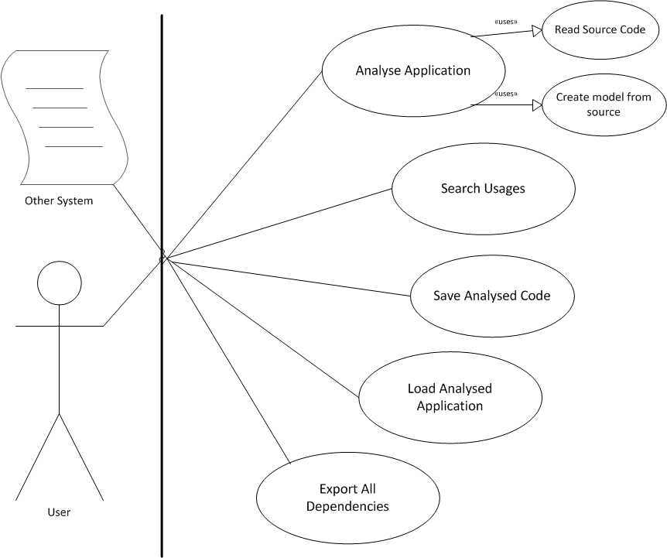

## 2.2. ANALYSE API

In order for other systems to be used, the analyse-component provides a set of functions that can be called. The API actually represents the implementations of the use cases mentioned In chapter 2.1. These functions can be called from the IAnalyseService interface. In order to work with the API, some DTO’s are returned when calling services of the API.

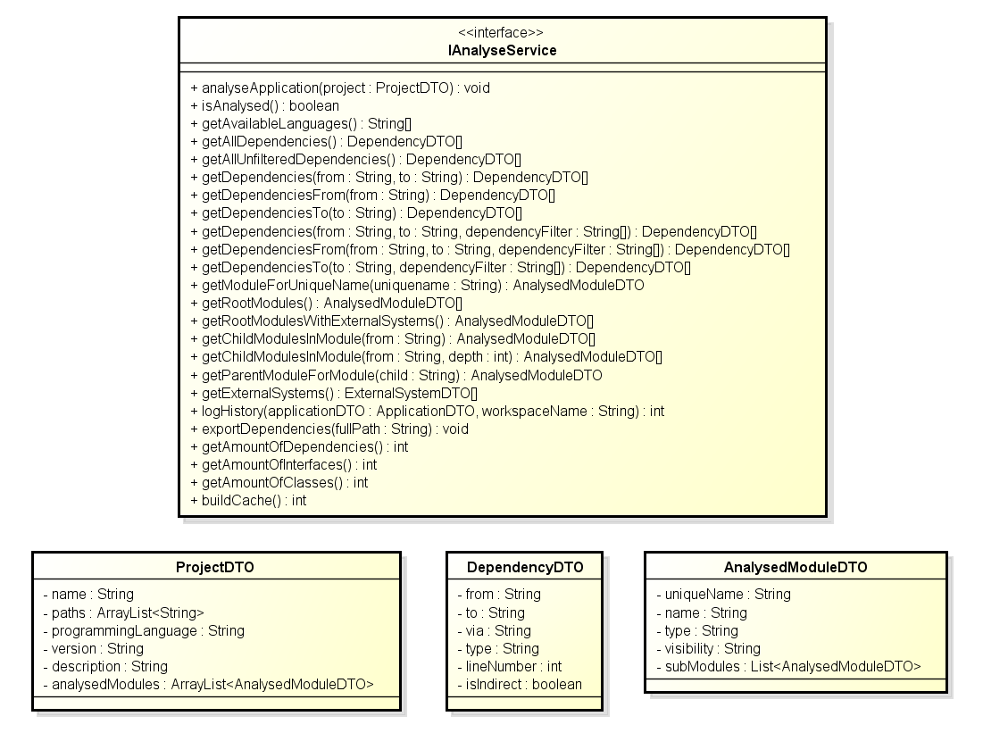

## 2.3 CONTEXT DIAGRAM

To give a better understanding about the analyse component we need to display it with all the other components. As you can see in the figure below, there are components depending on the analyse component. When requested, analyse can return filtered dependencies and external systems.

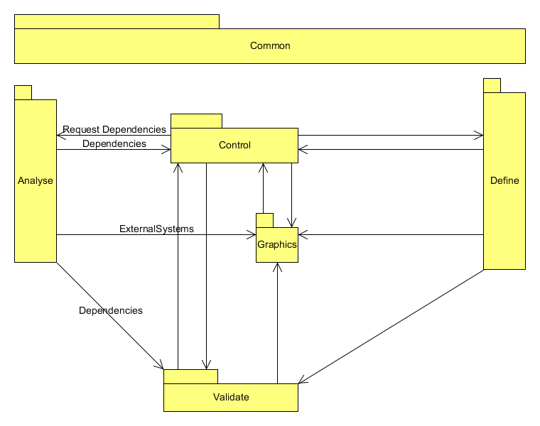

## 2.4 TOP LEVEL PACKAGES

This diagram shows the five packages that are inside the analyse service.

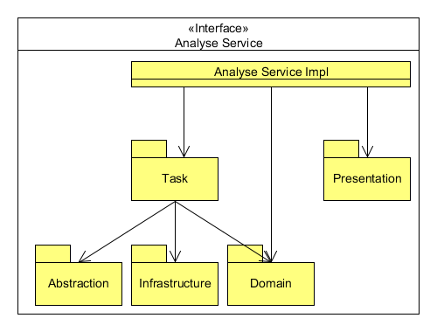

## C:\Users\Alex Xia\Documents\Dropbox\TCIF-V3TOASE1-12 ANALYSE\HUSACCT Analyse Documentation 2013\Diagrams\DecompositionDiagram.png2.5 DECOMPOSITION DIAGRAM

Every important package is listed in this diagram. To improve further functionality for indirect and direct dependencies, see the famix and ANTLR packes.

## 2.6 ANALYSE – CLASSES, LAYERS & ENCAPSULATION

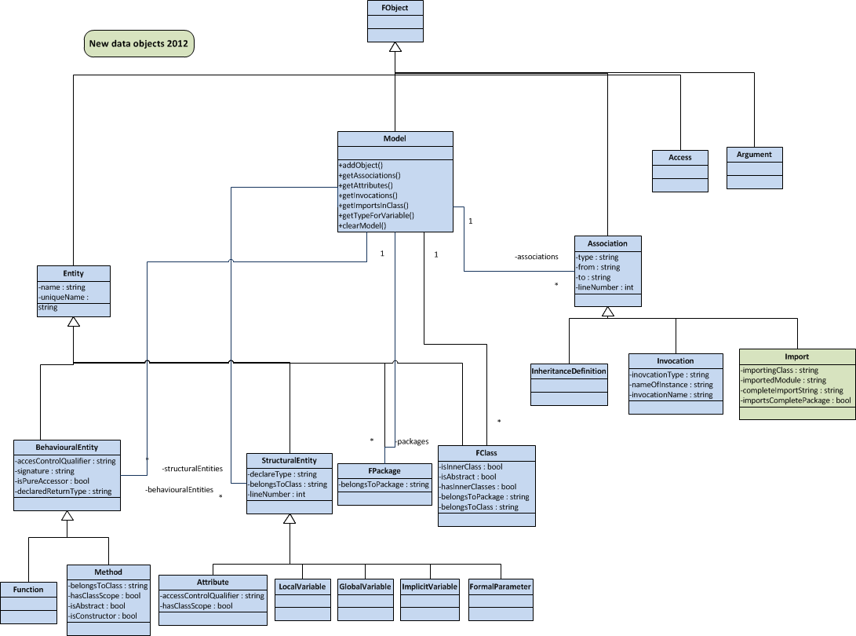

More information about the Famix-model or datastructure can be found in appendix 1. Some things about this

model are semantically relevant to let the analyse-component work correctly and as expected.

## 2.7. USE CASE DESCRIPTIONS

In order to understand the meaning of each use case, this chapter will provide a short motivation for each use case, and provide information on how these use cases are implemented.

### 2.7.1. Analyse Application

Let’s start off with the most important use case: Analyse Application.

|  |  |
| --- | --- |
| **Table 1.0. Textual Specification *Analyse Application*** | |
| Goal | Read source-file from a given directory and turn them to a model that can be used to efficiently search dependencies between different modules. |
| Implementation Area | - husacct/analyse/task/analyser/*  (Language-specific source-analysers)  - husacct/analyse/domain/famix/*  (The domain that will be filled)  - husacct/analyse/domain/IModelCreationService.java  (The API that the analyse-domain provides to fill the model. )  - husacct/analyse/domain/famix/FamixCreationServiceImpl.java  (Famix-implementation of the IModelCreationService.java) |
| Extra Info | The source-specific analysers are only allowed to fill the model via the IModelCreationService. The domain-model is encapsulated and by filling it via the IModelCreationService it is ensured that it will work independent from the programming-language in which the source-code is written.  The domain-model is wrapped by services similar to the IModelCreationService. This enables developers in the future to create their own implementation of the model, thus they can (for some reason), add or replace the model-implementation of famix by creating a custom domain and implementing those services.  This is the only use case that is dependent of another component or situation. The application path must have been set before this function is called, otherwise no source-files will be found. In it’s implementation it is dependent on IDefineService. |

### 2.7.1.1. Analyse Application – Selecting the correct Analyser

The following figure will clarify how the correct analyser is created when this use case is implemented.

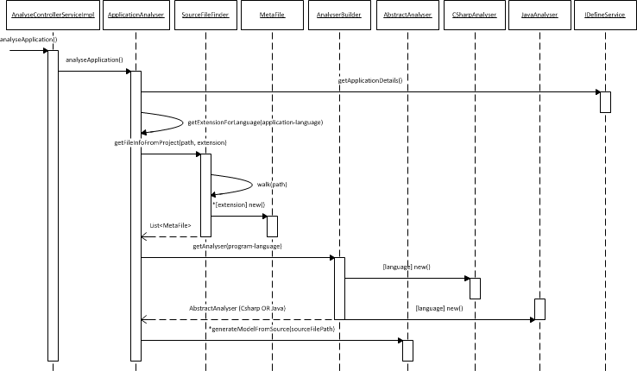

### 2.7.1.2. Analyse Application – Selecting the correct Analyser

To clarify both how a generator can be implemented, and is implemented for java, and how generators can create a generic model via a interface that the domain-model provides, a sequence diagram was drawn up. The following sequence diagram will show how these two things can be successfully implemented.

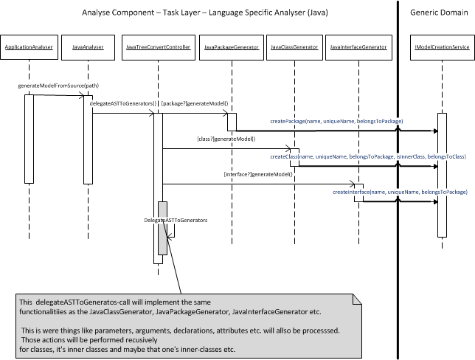

### 2.7.2. Search Usages & Search Modules

Another very important use case of this system is searching and returning dependencies between given modules. This chapter gives a short overview of this use case.

|  |  |
| --- | --- |
| **Table 1.1. Textual Specification *Search Usages*** | |
| Goal | Return dependencies, with their types and info, between given modules.  Return Modules, at root level or inner modules. |
| Implementation Area | Available Services:  - husacct/analyse/IAnalyseService  Important usage implementation area:  - husacct/analyse/domain/IModelQueryService  - husacct/analyse/domain/famix/FamixQueryServiceImpl  - husacct/analyse/domain/famix/FamixDependencyFinder  Import module implementation area:  - husacct/analyse/domain/IModelQueryService  - husacct/analyse/domain/famix/FamixQueryServiceImpl  - husacct/analyse/domain/famix/FamixModuleFinder |
| Extra Info | The code has to be analysed before requesting this use case. |

Because of the fact that the implementation of this use case is actually implemented in the famix implementation, and is located in one place, a class model will show how it is implemented.

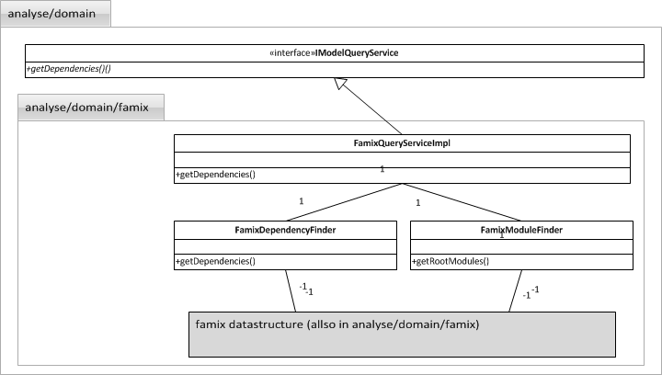

### 2.7.3. Save analysed application

A functionality to save the analysed domain-model, in this case famix, to an XML-element that can be used in a HUSACCT-workspace, some actions has to been done via a IModelPersistencyService. The global workings are listed in the figure below.

|  |  |
| --- | --- |
| **Table 1.2. Textual Specification *Search Usages*** | |
| Goal | Save the analysed model to an XML-Element. |
| Implementation Area | Available Services:  - husacct/analyse/IAnalyseService  Important usage implementation area:  - husacct/analyse/domain/IModelPersistencyService  - husacct/analyse/domain/famix/FamixPersistencyServiceImpl |
| Extra Info | This is a service that is called from another component, the Control-component of the HUSACCT. |

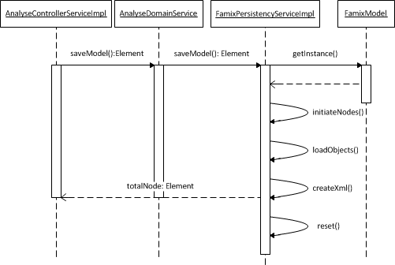

### 2.7.4. Load Analysed Application (from xml element)

To load an analysed application back into the model from a given XML-element, this functionality is implemented. To give a global overview of the implementation, a sequence diagram was drawn that shows how the modules en dependencies are created again from an xml element.

|  |  |
| --- | --- |
| **Table 1.3. Textual Specification *Search Usages*** | |
| Goal | Loadananalysed model to an XML-Element. |
| Implementation Area | Available Services:  - husacct/analyse/IAnalyseService  Important usage implementation area:  - husacct/analyse/domain/IModelPersistencyService  - husacct/analyse/domain/famix/FamixPersistencyServiceImpl |
| Extra Info | This is a service that is called from another component, the Control-component of the HUSACCT. |

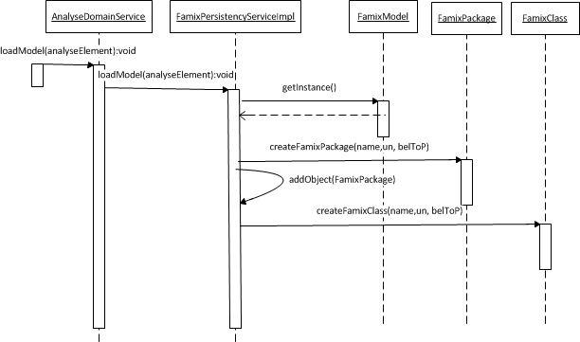

## 2.8 FUNCTIONAL REQUIREMENTS

A list of functional requirements isgiven in for this component.

|  |  |  |
| --- | --- | --- |
| **Table 2.0. Analyse Functional Requirements** | | |
| F # | Requirement | |
| F1 | Analysing java-code into a domain model | |
| F2 | Analysing c#-code into a domain model | |
| F3 | Find dependencies between modules | |
| F4 | All dependencies with the following types of dependencies can be recognized | |
| 1 | Invocation of a method |
| 2 | Invocation of constructor |
| 3 | Extending an abstract class/struct |
| 4 | Extending a concrete class/struct |
| 5 | Extending an interface |
| 6 | Implementing an interface |
| 7 | Declaration of a type |
| 8 | Annotation of a type |
| 9 | Throw an exception of a type |
| 10 | Imports of a type. |

## 2.9 NON-FUNCTIONAL REQUIREMENTS

With vision for future development and the common requirements for SACC-tools, a list of non-functional requirements was made for the analyse-component.

|  |  |  |
| --- | --- | --- |
| **Table 2.1. Analyse Non-functional Requirements** | | |
| NF # | ISO 9123 attr. | Requirement |
| NF1 | Maturity | The tool must not go down in case of a failure, but generate a meaningful error message. |
| NF2 | Fault Tolerence | There must be no restrictions in the size of the project regarding number of classes, lines of code, components... |
| NF3 | Time Behaviour | Tools must not take long (<= 15 min; 1.000.000 LOC) to analyse/validate the code, and togeneratean error report. |
| NF4 | Analyseability  Testability | Taking over the development of the tool by other development teams must be unproblematic. |
| NF5 | Changeability | The tool must be easily extendable to other code languages. |

## 2.10 DECISIONS AND JUSTIFICATIONS

Because of the non-functional requirements and the functional requirements, some important architectural decisions were made. The table below lists those decisions.

|  |  |
| --- | --- |
| **Table 2.2. Analyse Decisions & Justification** | |
| Decision | Justification |
| String filterswillbeused for incoming calls, so the validate component canquickly analyse the filter and return the right information. Thesefilters are alsoused to filter information to certain conditions. | NF 3. |
| Famixwillbeused as an independent data domain model structure. Famixenables the translation differentprogramminglanguagesinto one completedomain model, which an upper layer can use. As new programminglanguages are added to the tool, the FAMIX-model canbemodified by adding extra data. | NF 5. |
| Becausetherewas a lot of confusion about the workings of PMD whichcouldn’tbealtered in the team’sfavourite, Antlr has been used for the convertionfrom source files to Abstract SyntaxTree. Antlr uses socalledgrammars for this. Grammarscanbewritten for anyprogramminglanguage, whichmeansthatotherlanguagescanbeimplementend in the future.  For more information about ANTLR: http://www.antlr.org/ | NF 4.  NF 5. |
| The domain-generatorswillprocesscodebases in twosteps. At first, the codebasewillbeconverted in an AST (Abstract SyntaxTree). The second stepis to convert the AST to the FAMIX-model. Usingthissteps, itwillbeeasier for developers to replace the FAMIX-model withanother model. | NF 5. |
| The language-specificgeneratorscanfill the domain model via the IModelCreationService. This allowsotherlanguage-specificgenerators to fill the domain via the same service and thuswith the same type of parameters and values. | NF 5. |

# 3. Analyse Partitioning

In order to deliver and maintain a stable and expandable system, some rules and architectural styles were followed. This chapter shows those styles and their rules.

## 3.1. LOGICAL LAYERS & ACHITECTURAL RULES

This component follows a specific layered-model and specific rules for that layered model. This chapter will show this model and it’s rules.

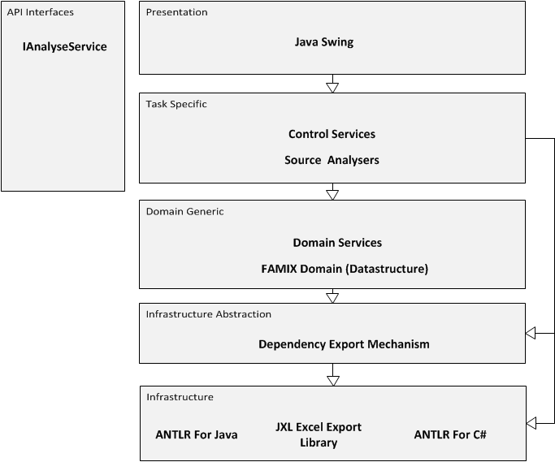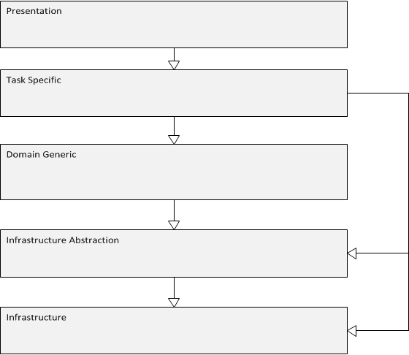

|  |  |
| --- | --- |
| **Table 3.1. Architectural Rules of the analyse component** | |
| # | Rule |
| 1 | The task=specific layer is only allowed to use the domain-layer via IModelCreationService, IModelPersistencyService or IModelQueryService. |
| 2 | Task=specific layer can only be accessed via the IAnalyseControlService |
| 3 | The task-specific layer is allowed to use the infrastructure layer for external libraries that helps code-translaters like the JavaAnalysers to translate code into a specific domain. |
| 4 | The task-specific layer is allowed to use the infrastructure abstraction layer, but only to use export mechanisms. |

## 3.2. COMPONENT PARTITIONING

In order to follow the layered-models that are created for this component, and to meet the non-functional requirements, the following partitioning has been implemented.

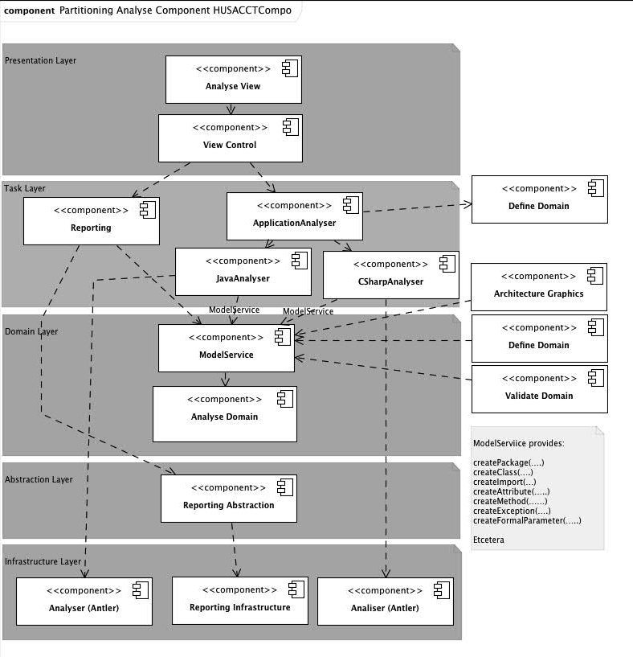

All of the components that can be seen on the previous page are really parts of the analyse-component. To understand to what these component are actually mapped, the following listing will list all mappings.

|  |  |  |
| --- | --- | --- |
| **Table 3.2. Husacct Analyse – Software Mapping to physical components** | | |
| Analyse | Analyse View | Husacct/analyse/presentation/AnalyseDebuggingFrame.java  Husacct/analyse/presentation/AnalyseInternalFrame.java  Husacct/analyse/presentation/ApplicationStructurePanel.java  Husacct/analyse/presentation/DependencyPanel.java  Husacct/analyse/presentation/DependencyTableModel.java  Husacct/analyse/presentation/ExportDependenciesDialog.java  Husacct/analyse/presentation/FileDialog.java  Husacct/analyse/presentation/Regex.java  Husacct/analyse/presentation/SoftwareTreeCellRenderere.java  Husacct/analyse/presentation/ThreadedDependencyExport.java |
| View Control | Husacct/analyse/presentation/AnalyseUIController.java |
| Reporting | Husacct/analyse/task/DependencyExportController.java |
| Application Analyser | Husacct/analyse/task/analyser/ApplicationAnalyser.java  Husacct/analyse/task/analyser/AbstractAnalyser.java  Husacct/analyse/task/analyser/AnalyserBuilder.java  Husacct/analyse/task/analyser/MetaFile.java  Husacct/analyse/task/analyser/SourceFileFinder.java |
| Java Analyser | Husacct/analyse/task/analyser/java |
| C# Analyser | Husacct/analyse/task/analyser/csharp |
| ModelService | Husacct/analyse/domain/IModelCreationService.java  Husacct/analyse/domain/IModelPersistencyService.java  Husacct/analyse/domain/IModelQueryService.java |
| Analyse Domain | Husacct/analyse/domain/famix/* |
| Reporting Abstraction | Husacct/analyse/abstraction/storage |
| Reporting Infrastructure | JXL-Library |
| Analyser(Antler) | Husacct/analyse/infrastructure/anlt/java  Husacct/analyse/infrastructure/anlt/csharp  Husacct/analyse/infrastructure/anlt/grammars/csharp  Husacct/analyse/infrastructure/anlt/grammars/java |

# 4. Testing the analyse component

In order to give a short introduction to how to check new analysers and the general part of this component, this chapters explains a few things about the tests.

## 4.1. TESTING DEPENDENCIES & MODULE-FINDERS

The dependencies and modules are tested in husacttest/analyse/benchmark/accuracy and husacttest/analyse/blackbox. These are general tests for checking main functionalities of the analyse component. To test every specific direct and indirect dependency you will need to open the “DependencyDetectionAccuracyTest.Java” shown in the figure below.

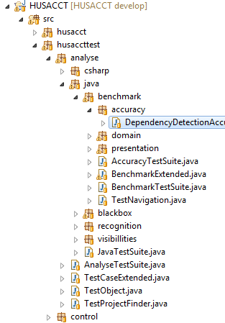

## 4.2. TESTING LANGUAGE-SPECIFIC ANALYSERS

In order to test language-specific analysers, an application-structure was made in the root folder of the husacct-project. These test-applications are made to test al different types of declarations in code and see if those are correctly generated from code to the model. The following figure will show which tests applies to which test-applications.

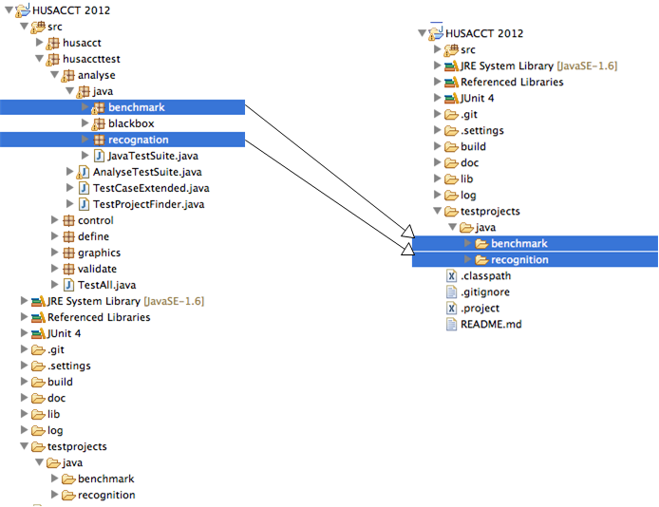

# 5. Adding support for new programming languages

In order to add support for new Object Oriënted programming-languages, some steps have to be followed. This chapter explains those steps.

## 5.1. CREATE A NEW ANALYSER

• Create a new package in the husacct/analyse/task/analysers and place your analyser in that class, for example husacct/analyse/task/analysers/php.

• Create a new class in the new package, that extends AbstractAnalyser and implement the required functions. (if it’s not directly obvious how to do this, check out the other analysers)

## 5.2. MAKE YOUR ANALYSER AVAILABLE FOR THE APPLICATION

In order to make your analyser available for the HUSACCT-application, after having implemented the previous steps, you have to add some code to the class husacct/analyse/task/analysers/AnalyserBuilder.java.

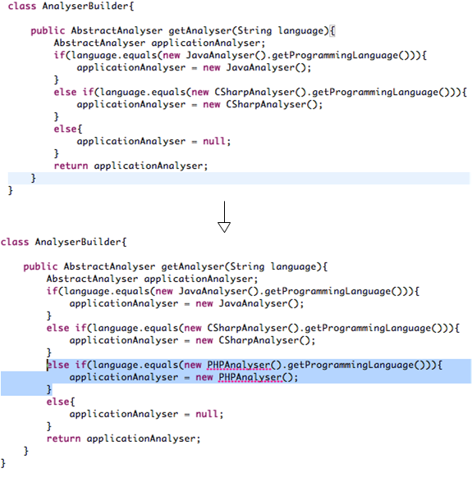

## 5.3. START CREATING YOUR ANALYSER-FUNCTIONALITY!

After you have implemented the previous two steps, you can now start developing your new tests. The following table consists of some rules, hints and tips for implementing a new analyser.

|  |  |  |
| --- | --- | --- |
| **Table 4.1. Rules, Tips & Hints for new analysers** | | |
| # | Type | .. |
| 1 | **Rule** | **The model may only be filled via the IModelCreationService!** |
| 2 | **Rule** | **Let all classes implement an abstract class, just like in the java-generators, which contains a reference to the IModelCreationService. This is a good implementation because of maintainability, expandability and replaceabillity-reasons.** |
| 4 | **Hint** | **Carefully test your generators after each step using JUnit tests.** |
| 5 | **Hint** | **Read the appendix about the FAMIX-model in HUSACCT before starting the development of the new analyser. This document explains each parameter and the sematics of parameters.** |
| 6 | **Tip** | **If you don’t know something, just checkout one of the existing analysers to see how they have implemented their functionality!** |

## 5.4. CREATING JUNIT TESTS FOR YOUR NEW ANALYSER

Last but not least some information about how to create new JUnit tests for the new analyser and some rules and important know-hows. Where to put your test-project, is already listed in chapter 4.2. (see the example image).

|  |  |  |
| --- | --- | --- |
| **Table 5.1. Rules, Tips & Hints JUnit-tests for your new analyser** | | |
| # | Type | .. |
| 1 | **Rule** | **Due to build-issues the path to your application has to be set via the a function in the TestProjectFinder.java.**  **Example:** String path = TestProjectFinder.*lookupProject*("java", "recognition"); |
| 2 | **Tip** | **If you don’t know something, just checkout one of the existing analysers to see how they have implemented their functionality!** |

# 6. Additional Information

All images and designs shown in this document are also available at github under the following url:

https://github.com/HUSACCT/HUSACCT/tree/master/doc/analyse

# Appendix 1. HUSACCT Famix Implementation & Description

## Introduction

The Famix model is a domain that takes care of holding all analysed code information in an organized order, stored in objects. This is made in such a way that this is language independent. There is already Famix documentation, but because the team members have altered this model a bit to suit their needs, this document will serve as a specific guide for the Husacct Tool.

This document provides the workflow of the Famix Model as well as all the classes and it’s attributes. Examples will be given with code, but these will be purely Java based.

Remember that a full UML diagram is given at the end of this document. It is very useful to use this as a reference point while you go through this document if you want to fully understand the HusacctFamix Model.

## Workflow

The Model class is basicly the center of the domain. Every object that is analysed and put into the domain will go through the addObject() method in the Model class. The model also contains a list of all the attributes and associations, so the queryservice can ask all it’s ‘get’ questions to this Model. It is that the Model is so important, that the descision was made to make this a Singleton. This doesn’t have any negative consequences as you can only analyse one application at a time.

There are two kinds of dependencies. Real invocations which belong to the Associations, and there are the declarations which belong to the StructuralEntity types. The StrucuralEntities are purely used for inner workings and should not be seen as a direct dependency. Dependencies are always represented by the Associations. That is the place where the real dependecies are stored and recieved from, once the analysation is over. Here is an example :

User testuser = new User() ;

The first green part is the declaration of testuser being a User. This will be stored as an Attribute which extends the StructuralEntity. Then the second red part is the actual invocation, in this case a constructor invocation. This will be stored as an Invocation which extends Association. More on this later. For now it is important to know that the Famix Model holds these 2 sorts of dependencies : Associations and StructuralEntities.

## Class Descriptions

Within this part of the document the most important classes’s properties are explained.

|  |  |
| --- | --- |
| FamixEntity | **TODO** |
| Name | The name of the entity |
| uniqueName | The whole unique name of the entity beginning with the package it belongs to |

|  |  |
| --- | --- |
| FamixBehaviouralEntity | Extends Famixentity. Containing the Functions and the Methods. The Husacct Tool doesn’t see distinction between these two kinds and stores every method and function in the FamixMethod class. |
| accessControlQualifier | Public, private, protected or package private |
| signature | The method name including the parameters types. i.edoSomething(String, int) |
| isPureAccessor | Whether it is static or not. |
| declaredReturnType | The return type if not void. |

|  |  |
| --- | --- |
| FamixMethod | Extends FamixBehaviouralEntity. Contains all the functions and Methods. The Husacct Tool doesn’t see distinction between these two kinds and stores every method and function in the FamixMethod class. |
| belongsToClass | The unique name of the class containing the method. |
| hasClassScope | **TODO** |
| isAbstract | Whether the method is abstract or not. |
| isConstructor | Whether the method is a constructor or not. |

|  |  |
| --- | --- |
| FamixPackage | Extends FamixEntity. Represents a physical package. |
| belongsToPackage | The unique name of the package it belongs to. This doesn’t work for the root package, but does work for inner packages. |

|  |  |
| --- | --- |
| FamixClass | Extends FamixEntity. Represents a physical class. |
| isInnerClass | Boolean representing whether the class is an inner class |
| isAbstract | Boolean representing whether the class is abstract |
| hasInnerClasses | Boolean representing whether the class has inner classes. |
| belongsToPackage | The unique name of the package that the class belongs to |
| belongsToClass | The unique name of the class that the class belongs to. Works only for inner classes. |

|  |  |
| --- | --- |
| FamixStructuralEntity | Extends FamixEntity. FamixStructuralEntity is a superclass over attributes, variables and parameters. |
| declareType | The uniqueName of the class that the entity refers to |
| belongsToClass | The unique name of the class that the entity belongs to. |
| lineNumer | The linenumber where the entity can be found in the class. |

|  |  |
| --- | --- |
| FamixAttribute | Extends FamixStructuralEntity. Represents an attribute. An attribute looks like as follows: User testUser; testUser is the name of the attribute while it refers to the class called ‘User’. |
| accessControlQualifier | Public, private protected or package-private |
| hasClassScope | Indicates whether the attribute is static or not |

|  |  |
| --- | --- |
| FamixFormalParameter | Extends FamixStructuralEntity. Represents a parameter. |
| belongsToMethod | The unique name of the method it belongs to. |
| declaredTypes | The return type of a parameter could simply be a String, int, double etc but it can also be a list containing other declaredTypes such as arrayLists and Hashmaps.  In that case, all of the items from that list can be stored in declaredTypes.  i.e. if this is a parameter: HashMap<User, HomeAddress> then the returntype is still a HashMap, but now the declaredTypes have 2 properties: a User and a HomeAddress object. |
|  |  |
| Extra info | There are agreements about how to store the uniquename of a parameter. Say we have i.e. the following method with two parameters:  doSomething(String varString, intvarInt)  the uniquename of the first parameter varString looks as followed:  ‘uniqueclassname.doSomething(String, Int). varString’ |

|  |  |
| --- | --- |
| FamixLocalVariable | Extends FamixStructuralEntity. Represents an attribute within a method or function. |
| belongsToMethod | The unique name of the method it belongs to. |
|  |  |
| Extra info | There are agreements about how to store the uniquename of a local variable. Say we have i.e. the following method:  doSomething(String varString){  IntvarInt = 0;  }  The uniqueName of the local variable varInt looks as followed:  ‘uniqeclassname.doSomething(String).varInt’ |

|  |  |
| --- | --- |
| FamixAssociation | FamixAssociation is a superclass, that each kind of dependency can extend. |
| Type | The type of the dependency. Although you can see what kind of dependency it is by checking it’s instance of the subclass, there are dependencies which have different kind of types within that same subclass. Examples are: import, declaration, implements, extends etc |
| From | The unique name (package.classname) of the class which contains the dependcy |
| To | The unique name of the class which the dependency refers. |
| lineNumber | The linenumber where the dependency can be found in the class. |

|  |  |
| --- | --- |
| FamixInvocation | Extending FamixAssociation. Invocation is an invocation of a class. There are three kind of invocations: 1) invocConstructor: This is the type when a new object is created i.e. ‘new User();’  2) invocMethod: When a method is called in an object.  3) accessPropertyOrField: When a public attribute is called in an object. |
| invocationType | **TODO** |
| nameOfInstance | The name of the method or public attribute that is called. |
| invocationName | The name of the object within the class that holds the dependency. |

|  |  |
| --- | --- |
| FamixImport | Extending FamixAssociation. Imports are usually declared at the beginning of a class and holds a reference point to the class or package some dependencies refer to. |
| importingClass | The unique name (package.classname) of the class which contains the import |
| completeImportString | The complete string of the import i.e. husacct.package1 or husacct.package1.* |
| importCompletePacakge | Boolean. Indicates whether the import imports a single class or a whole package with the * symbol. |